Lab 03 Report
Leo Bolaks
C00299368

To configure my environment I first attempted to install all the necessary packages needed using the various pacman commands
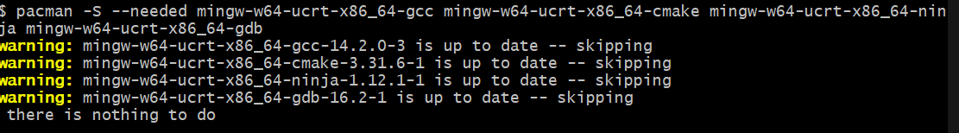
I then added the msys2/ucrt64 path to my environmental variables by adding a new line on the path section of my user environment variables.
After which I ran the 3 version commands to test whether it was linked successfully and my terminal is recognising the tools I installed.
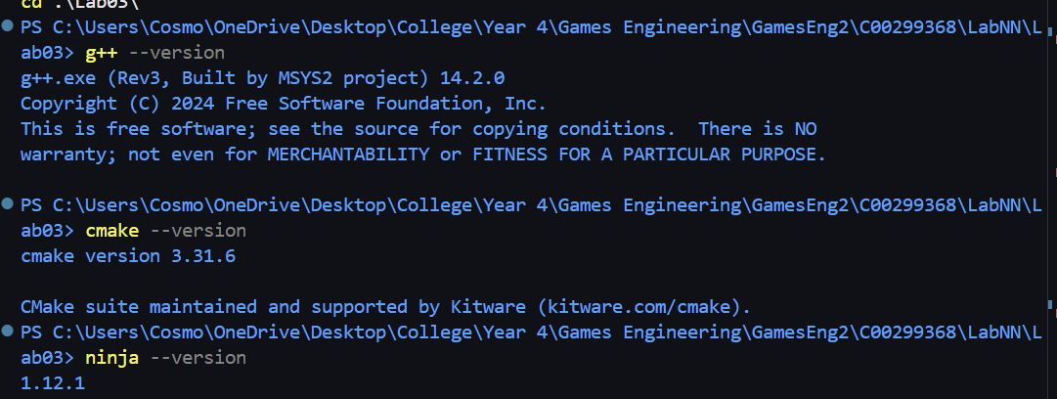
After checking that the tools have been installed successfully, I ran the initial cmake build setup for this lab03 folder which used the googleTest linked in the CMakeLists.txt
After the initial set up was done and the build was created, I ran that specific build with the target being lab03_tests, that builds the solution, after building the solution I run the actual build using ./build/lab03_tests which ran the tests and displayed them in colour using –gtest_color=yes. Passing tests showed up in green and failing tests showed up in red.

Using frameworks allows me to scale up my tests due to its simplicity, you write a simple test and can run all of them simultaneously with 1 command, from which it clearly displayed which tests passed and which tests failed making it very easy to see which parts of your programme are failing. Frameworks can also easily allow you to test any part of your code with no special set up from the user.

